RECO: Intelligent E-Commerce Platform with Recommendation Engine

Requirements & Initial Design Document

Description
RECO is a full-stack intelligent e-commerce platform designed to simulate a real-world online shopping experience with a built-in recommendation engine. The system addresses the problem of product overload in modern e-commerce platforms by providing users with personalized product suggestions, while also offering a complete end-to-end shopping flow including a mock payment system.

Problem Statement
Modern e-commerce platforms contain massive product catalogs, which often lead to:
- Decision fatigue
- Abandoned shopping carts
- Difficulty finding relevant products
Additionally, real payment integrations are difficult to implement in academic environments.

Solution
RECO solves these challenges by providing:
- A self-contained e-commerce system
- A mock payment gateway for simulated checkout
- A data-driven recommendation engine that adapts to user behavior

Target Users
- Customers: Browse and search products, manage cart and orders, receive personalized recommendations, complete simulated checkout process
- Administrators: Manage product catalog (CRUD), monitor orders, control inventory system

Functional Requirements

FR-1: User Authentication & Authorization
- FR-1.1: Users shall be able to register with email, password, and profile information
- FR-1.2: Users shall be able to log in using JWT-based authentication
- FR-1.3: System shall support role-based access control (Admin / Customer)
- FR-1.4: Users shall be able to update their profile information
- FR-1.5: System shall securely store passwords using hashing
- FR-1.6: Users shall be able to delete their accounts

FR-2: Product Catalog Management
- FR-2.1: Admins shall be able to create, read, update, and delete products
- FR-2.2: Products shall include name, description, price, category, image, and stock quantity
- FR-2.3: Customers shall be able to browse and search products by name, category, or tags
- FR-2.4: System shall display product details including recommendations
- FR-2.5: System shall support product pagination and filtering

FR-3: Shopping Cart Functionality
- FR-3.1: Customers shall be able to add products to their shopping cart
- FR-3.2: Customers shall be able to update quantities or remove items from cart
- FR-3.3: System shall calculate cart totals including all items
- FR-3.4: Cart data shall persist across user sessions

FR-4: Order Processing System
- FR-4.1: Customers shall be able to place orders from their cart
- FR-4.2: System shall generate unique order IDs and timestamps
- FR-4.3: System shall track order status (pending, processing, shipped, delivered)
- FR-4.4: System shall notify the user about order stats
- FR-4.5: Customers shall be able to view their order history
- FR-4.6: Admins shall be able to view and manage all orders

FR-5: Mock Payment Gateway
- FR-5.1: System shall simulate a checkout flow (Cart → Payment → Order Confirmation)
- FR-5.2: System shall accept mock payment information
- FR-5.3: System shall generate payment records with transaction details
- FR-5.4: No external payment APIs shall be required

FR-6: Hybrid Recommendation Engine
- FR-6.1: System shall provide Cold Start Strategy recommendations for new users (popular products)
- FR-6.2: System shall provide Content-Based Filtering recommendations based on category/tags similarity
- FR-6.3: System shall provide Collaborative Filtering recommendations based on "users also bought" patterns
- FR-6.4: Recommendations shall be displayed on product detail pages and user dashboard
- FR-6.5: System shall analyze user behavior "purchases and reviews" to improve recommendations over time
- FR-6.6: System shall use products rated 4+ stars from reviews to find similar products via product similarity scores

FR-7: Product Reviews & Ratings
- FR-7.1: Customers shall be able to create reviews with a rating (1-5) and optional comment for purchased products
- FR-7.2: System shall automatically update the product's average rating when a review is created, updated, or deleted
- FR-7.3: Customers shall be able to view all reviews for a product with pagination and sorting (by rating or date)
- FR-7.4: System shall display a rating distribution breakdown (5-star to 1-star counts) for each product
- FR-7.5: Customers shall be able to update or delete their own reviews
- FR-7.6: System shall allow customers to view all reviews they have written across products

User Stories / Use Cases

UC-1: Customer Registration & Login
Actor: Customer
Description: As a new user, I want to create an account so that I can shop and receive personalized recommendations.
Flow:
- User navigates to registration page
- User enters email, password, and name
- System validates input and creates account
- User receives confirmation and can log in
- System generates JWT token for authentication

UC-2: Browse & Search Products
Actor: Customer
Description: As a customer, I want to browse and search products so that I can find items I'm interested in.
Flow:
- User views product catalog (paginated)
- User searches by keyword, category, or filters by price range
- System displays matching products with images, prices, and ratings
- User clicks on a product to view details and recommendations

UC-3: Add to Cart & Checkout
Actor: Customer
Description: As a customer, I want to add items to my cart and complete a purchase so that I can receive my order.
Flow:
- User clicks "Add to Cart" on a product
- System updates cart and shows confirmation
- User proceeds to checkout
- User enters mock payment information
- System processes mock payment and creates order
- User receives order confirmation

UC-4: View Personalized Recommendations
Actor: Customer
Description: As a customer, I want to see product recommendations so that I can discover items I might like.
Flow:
- User views product detail page or dashboard
- System analyzes user's purchase history and behavior
- System displays recommended products based on hybrid strategy
- User can click on recommendations to add to cart or view details

UC-5: Admin Product Management
Actor: Administrator
Description: As an admin, I want to manage the product catalog so that I can keep inventory up to date.
Flow:
- Admin logs into admin dashboard
- Admin creates/edits/deletes products
- System updates database and reflects changes immediately
- Admin can view stock levels and manage inventory

UC-6: Admin Order Monitoring
Actor: Administrator
Description: As an admin, I want to monitor and manage orders so that I can fulfill them efficiently.
Flow:
- Admin views all orders in dashboard
- Admin can filter by status, date, or customer
- System notifies customer of status changes

UC-7: Write & Manage Product Reviews
Actor: Customer
Description: As a customer, I want to leave reviews and ratings for products I purchased so that I can share my experience and help other shoppers.
Flow:
- User navigates to a product detail page
- User clicks "Write Review" and selects a rating (1-5) with an optional comment
- System validates input and creates the review record
- System recalculates the product's average rating and rating distribution
- User can later edit or delete their own review
- Other customers can view all reviews sorted by rating or date

Non-Functional Requirements

NFR-1: Performance
- NFR-1.1: API response time shall be under 200ms for standard requests
- NFR-1.2: Recommendation engine shall generate suggestions within 500ms
- NFR-1.3: System shall support concurrent users (minimum 100 concurrent sessions)

NFR-2: Security
- NFR-2.1: All passwords shall be hashed using bcrypt or equivalent
- NFR-2.2: JWT tokens shall expire after a configurable timeout (default: 24 hours)
- NFR-2.3: All API endpoints shall enforce role-based access control
- NFR-2.4: Sensitive data shall be transmitted over HTTPS in production

NFR-3: Scalability
- NFR-3.1: System shall be designed with a layered architecture for easy horizontal scaling
- NFR-3.2: Database queries shall be optimized with proper indexing
- NFR-3.3: Recommendation engine shall use SQL-based logic for efficient computation

NFR-4: Availability
- NFR-4.1: System shall maintain 99.5% uptime during business hours
- NFR-4.2: Database shall implement automatic backup procedures

NFR-5: Usability
- NFR-5.1: Frontend shall be responsive and mobile-friendly
- NFR-5.2: UI shall follow consistent design patterns
- NFR-5.3: Error messages shall be clear and actionable

NFR-6: Maintainability
- NFR-6.1: Code shall follow clean architecture principles (Controller → Service → Repository)
- NFR-6.2: API shall be fully documented using Swagger
- NFR-6.3: Unit tests shall cover critical business logic

Constraints & Assumptions

Constraints
- C-1: Academic Environment: Real payment gateway integration is not required; mock payment system suffices
- C-2: Tech Stack: Backend must use Java/Spring Boot; Frontend must use HTML/CSS/JavaScript with Tailwind CSS and Vite
- C-3: Database: Postgres is the designated relational database
- C-4: Recommendation Engine: Must use SQL-based recommendation logic (no external ML services)

Assumptions
- A-1: Users have modern web browsers with JavaScript enabled
- A-2: Product images and descriptions are provided by administrators
- A-3: Mock payment data does not need to be validated against real financial systems
- A-4: User behavior data (purchases, views) will be sufficient for recommendation accuracy
- A-5: System will start with a limited product catalog that can grow over time
- A-6: CORS is properly configured for frontend-backend communication during development
- A-7: Recommendation strategies (Cold Start, Content-Based, Collaborative) will be selected dynamically based on user data availability

High-Level Architecture

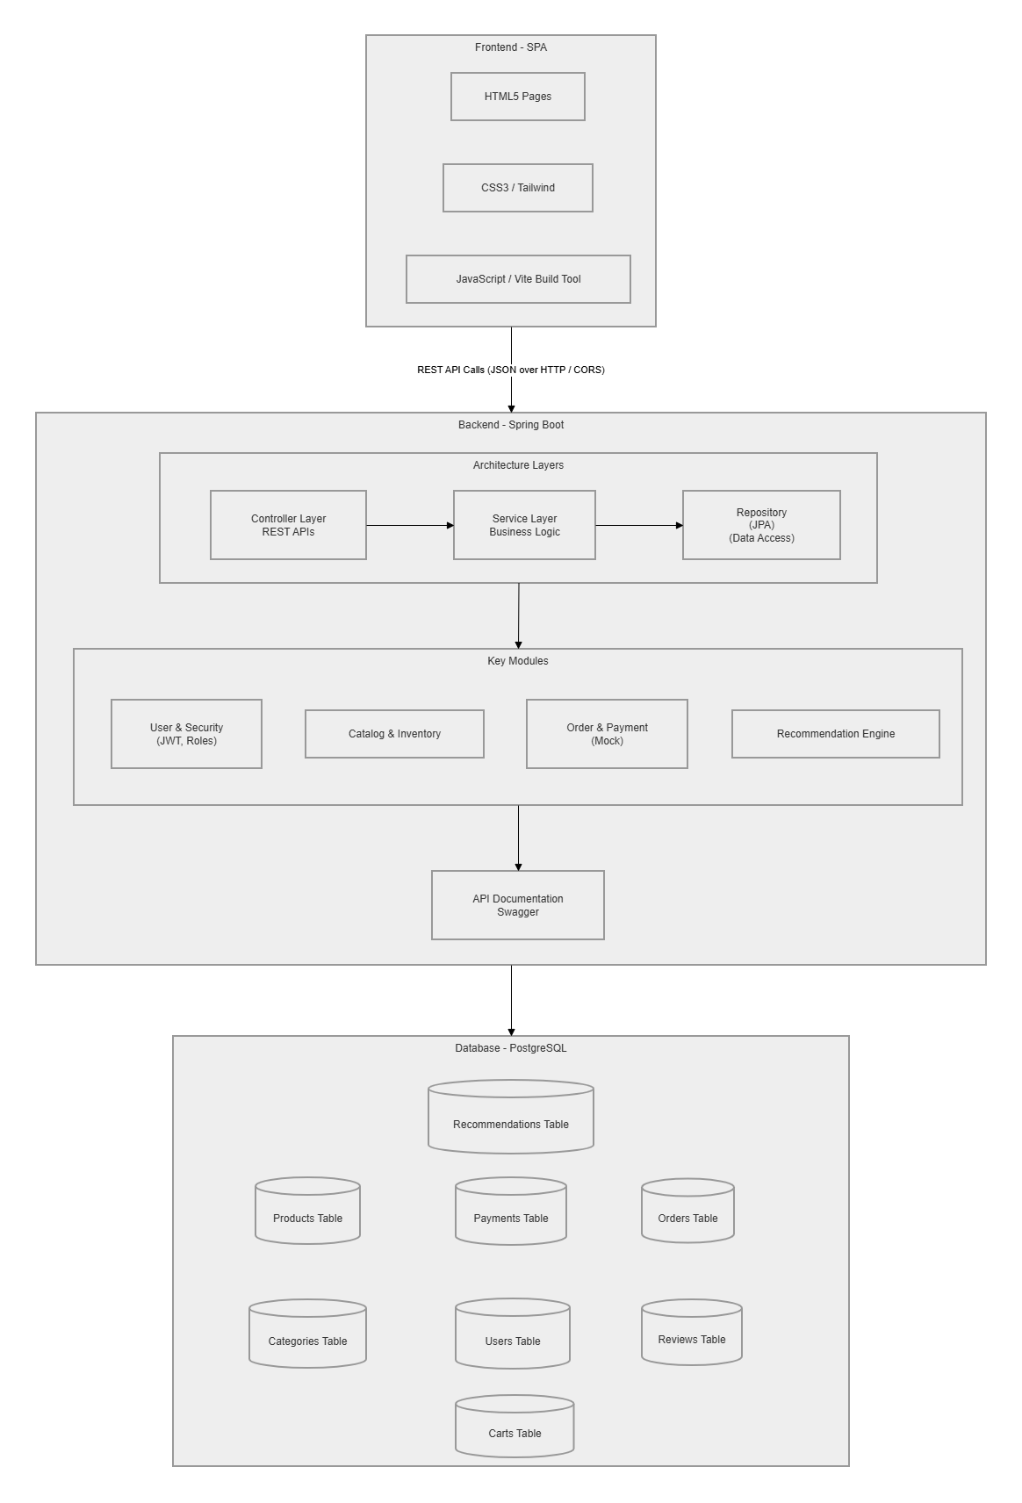

Architecture Layers
Layer | Responsibility
Frontend (SPA) | User interface, routing, state management, API communication
Controller Layer | REST API endpoints, request validation, response formatting
Service Layer | Business logic, recommendation strategy selection, payment processing
Repository Layer | Database operations via Spring Data JPA
Entity Layer | JPA entity mappings to Postgres tables

Selected Design Patterns

DP-1: Factory Pattern
Purpose: Dynamically select recommendation strategies based on user context
Justification: The hybrid recommendation engine needs to choose between three different strategies (Cold Start, Content-Based, Collaborative Filtering) depending on available user data. The Factory Pattern encapsulates this selection logic, making it easy to add new strategies in the future without modifying existing code.
Implementation:
- RecommendationFactory creates the appropriate strategy instance
- ColdStartStrategy: Returns popular products for new users with no history
- ContentBasedStrategy: Returns similar products based on category/tags
- Factory evaluates user data availability and selects the optimal strategy
Benefits:
- Open/Closed Principle: New strategies can be added without changing factory logic
- Single Responsibility: Each strategy handles its own recommendation logic
- Easy testing: Each strategy can be unit tested independently

DP-2: Builder Pattern
Purpose: Construct complex objects like Order and Product with multiple optional fields
Justification: Entities like Order and Product have many fields (some required, some optional). Using Lombok's @Builder annotation provides a fluent API for constructing these objects, improving code readability and reducing constructor complexity.
Implementation:
@Builder
public class Order {
private Long id;
private User customer;
private List<OrderItem> items;
private Payment payment;
private OrderStatus status;
private LocalDateTime createdAt;
// ...
}
Benefits:
- Readable object construction: Order.builder().customer(user).items(items).build()
- Immutability: Built objects can be made immutable
- Type safety: Compile-time checking of required fields
- Default values: Optional fields can have sensible defaults

DP-3: Singleton Pattern
Purpose: Ensure single instances of core services like MockPaymentGateway and RecommendationService
Justification: The mock payment gateway and recommendation service are shared resources that should have a single instance across the application. This ensures consistent state, reduces memory overhead, and provides a centralized point for configuration and logging.
Implementation:
- MockPaymentGateway: Single instance handles all mock payment transactions
- RecommendationService: Single instance manages recommendation strategy selection and caching
- Spring's @Service annotation provides singleton behavior by default
- Thread-safe: Spring manages singleton instances in a thread-safe manner
Benefits:
- Controlled access: Single point of access to shared resources
- Resource efficiency: Reduces memory and initialization overhead
- Consistent state: All components use the same instance
- Easy configuration: Centralized configuration and logging

Initial Class List

Core Domain Classes
Class Name | Responsibility | Key Attributes | Key Methods
User | Represents application users | id, email, password, name, role, createdAt | register(), login(), updateProfile()
Product | Represents catalog items | id, name, description, price, category, tags, imageUrl, stockQuantity | create(), update(), delete(), search()
Category | Product categorization | id, name, description, parentCategory | create(), getProducts()
Cart | Shopping cart for user | id, userId, items, totalAmount, createdAt | addItem(), removeItem(), updateQuantity(), checkout()
CartItem | Individual cart line item | id, cartId, productId, quantity, price | calculateSubtotal()
Order | Customer purchase record | id, userId, items, totalAmount, status, createdAt, paymentId | create(), updateStatus(), getDetails()
OrderItem | Individual order line item | id, orderId, productId, quantity, price | calculateSubtotal()
Payment | Payment transaction record | id, orderId, amount, status, transactionId, timestamp | processPayment()
Review | Product review and rating | id, userId, productId, rating, comment, createdAt, updatedAt | create(), update(), delete(), calculateAverageRating()
Recommendation | Product recommendation data | id, userId, recommendedProducts, strategy, generatedAt | generate(), getRecommendations()

Service Layer Classes
Class Name | Responsibility | Key Methods
UserService | User authentication and profile management | register(), authenticate(), generateToken(), updateProfile()
ProductService | Product catalog CRUD operations | createProduct(), updateProduct(), deleteProduct(), searchProducts(), getProductById()
CartService | Shopping cart operations | addToCart(), removeFromCart(), updateQuantity(), getCart(), calculateTotal()
OrderService | Order processing and management | createOrder(), getOrdersByUser(), updateOrderStatus(), getAllOrders()
PaymentService | Mock payment processing | processPayment(), refundPayment(), getPaymentDetails()
ReviewService | Review and rating management | createReview(), updateReview(), deleteReview(), getProductReviews(), getUserReviews(), calculateAverageRating()
RecommendationService | Hybrid recommendation engine | getRecommendations(), selectStrategy(), analyzeUserBehavior()

Recommendation Strategy Classes
Class Name | Responsibility | Key Methods
RecommendationStrategy (Interface) | Base strategy interface | getRecommendations(userId, limit)
ColdStartStrategy | Popular products for new users | getPopularProducts(), getTrendingProducts()
ContentBasedStrategy | Similar products by category/tags | getSimilarProducts(productId), getProductsByCategory(category)
CollaborativeFilteringStrategy | "Users also bought" recommendations | getUsersWhoBoughtThisAlsoBought(), getUserPurchaseHistory()
RecommendationFactory | Strategy selection factory | createStrategy(user)

Controller Layer Classes
Class Name | Responsibility | Key Endpoints
AuthController | Authentication endpoints | POST /api/auth/register, POST /api/auth/login
ProductController | Product catalog endpoints | GET /api/products, GET /api/products/{id}, POST /api/products, PUT /api/products/{id}, DELETE /api/products/{id}
CartController | Cart management endpoints | GET /api/cart, POST /api/cart/items, PUT /api/cart/items/{id}, DELETE /api/cart/items/{id}
OrderController | Order processing endpoints | POST /api/orders, GET /api/orders, GET /api/orders/{id}
PaymentController | Payment endpoints | POST /api/payments, GET /api/payments/{id}
ReviewController | Review endpoints | POST /api/products/{id}/reviews, GET /api/products/{id}/reviews, GET /api/users/{id}/reviews, PUT /api/reviews/{id}, DELETE /api/reviews/{id}
RecommendationController | Recommendation endpoints | GET /api/recommendations, GET /api/recommendations/product/{id}

Configuration & Utility Classes
Class Name | Responsibility
SecurityConfig | Spring Security and JWT configuration
CorsConfig | CORS configuration for frontend-backend communication
MockPaymentGateway | Singleton mock payment processor
JwtTokenUtil | JWT token generation and validation
ApiResponse | Standardized API response wrapper

Entity Relationships
- User (1) → (N) Cart
- User (1) → (N) Order
- Order (1) → (N) OrderItem
- Product (1) → (N) OrderItem
- Cart (1) → (N) CartItem
- Product (1) → (N) CartItem
- Order (1) → (1) Payment
- Category (1) → (N) Product
- User (1) → (N) Recommendation
- User (1) → (N) Review
- Product (1) → (N) Review

Endpoint Summary
Module | Endpoint | Method | Description
Auth | /api/auth/register | POST | Register new user
Auth | /api/auth/login | POST | User login
Products | /api/products | GET | List all products
Products | /api/products/{id} | GET | Get product details
Products | /api/products | POST | Create product (Admin)
Products | /api/products/{id} | PUT | Update product (Admin)
Products | /api/products/{id} | DELETE | Delete product (Admin)
Cart | /api/cart | GET | Get user cart
Cart | /api/cart/items | POST | Add item to cart
Cart | /api/cart/items/{id} | PUT | Update cart item
Cart | /api/cart/items/{id} | DELETE | Remove cart item
Orders | /api/orders | POST | Create order (checkout)
Orders | /api/orders | GET | Get user orders
Orders | /api/orders/{id} | GET | Get order details
Payments | /api/payments | POST | Process mock payment
Payments | /api/payments/{id} | GET | Get payment details
Recommendations | /api/recommendations | GET | Get user recommendations
Recommendations | /api/recommendations/product/{id} | GET | Get product-based recommendations
Reviews | /api/products/{id}/reviews | POST | Create review for product
Reviews | /api/products/{id}/reviews | GET | Get all reviews for product
Reviews | /api/users/{id}/reviews | GET | Get all reviews by user
Reviews | /api/reviews/{id} | PUT | Update own review
Reviews | /api/reviews/{id} | DELETE | Delete own review
Reviews | /api/products/{id}/rating | GET | Get product rating summary

Technology Stack
Layer | Technology
Backend | Java, Spring Boot, Spring Data JPA, Spring Security
Database | Postgres
Frontend | HTML5, CSS3, JavaScript, Tailwind CSS, Vite
Authentication | JWT (JSON Web Tokens)
API Documentation | Swagger / OpenAPI
Testing | Postman
Build Tool | Maven (Backend), Vite (Frontend)

Team Members
- Abdelrahman Hany Farouk (SE1)
- Ahmad Louay Mahmoud (SE1)
- Youssef Waleed (SE1)
- Youssef Khaled (SE1)

-This Document is paraphrased by Ai.

